1. General syntax for using aggregate function:

Db.collection.aggregate ([

{ $match : {<condition>} }

]);

1. Find all records where country is Egypt or China

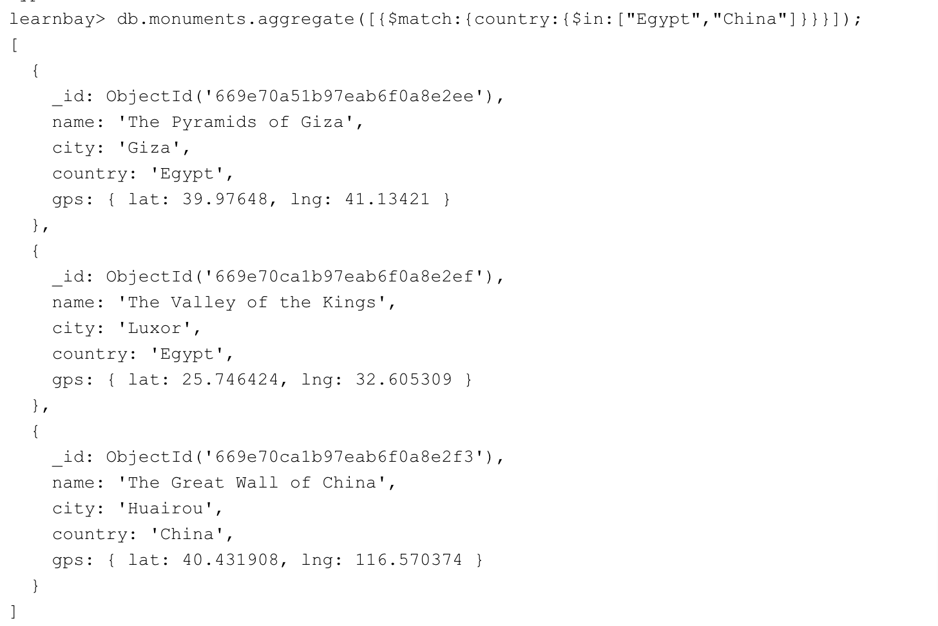

1. Cities in the continent North America and Asia

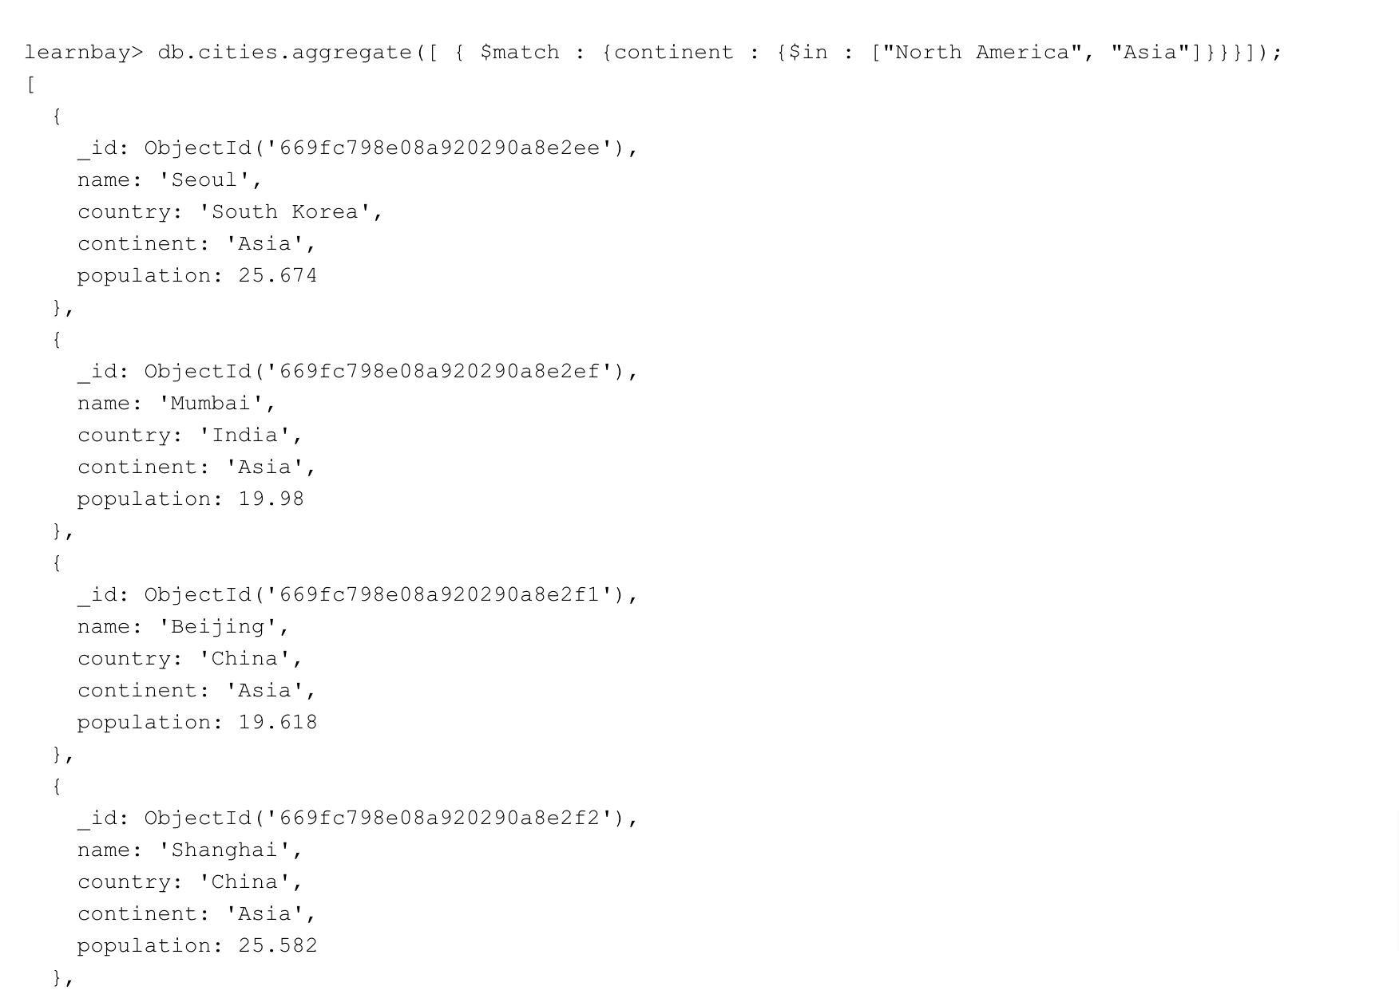

1. Show records with continent as North America or Asia and sort in descending order

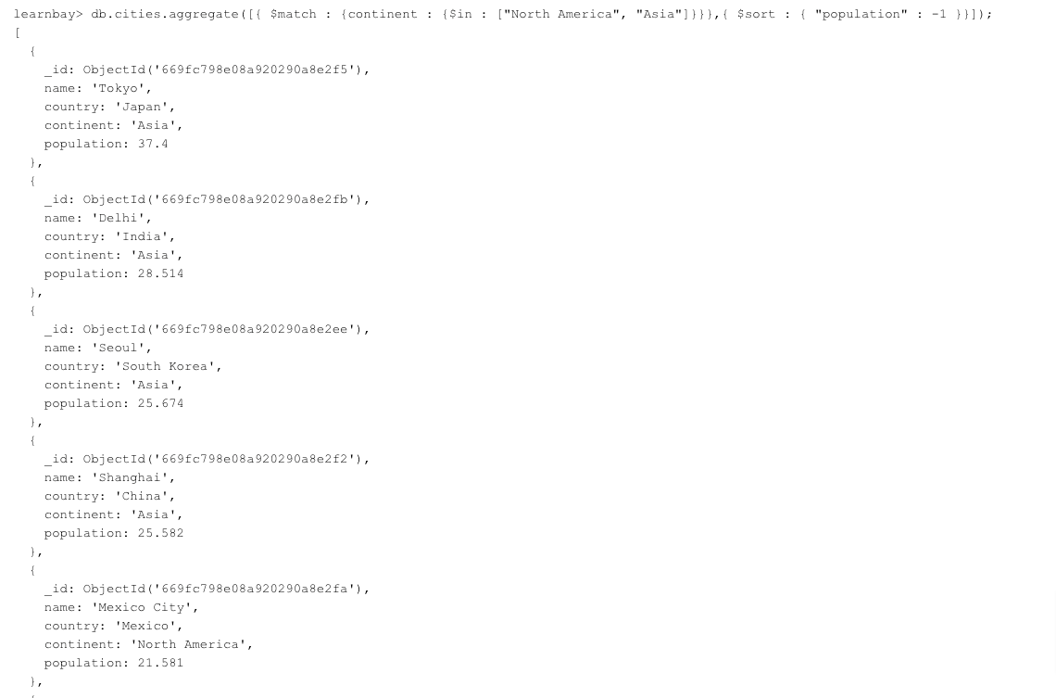

1. Using Group Aggregation Stage

$group aggregation is responsible for grouping and summarizing documents. It takes in multiple documents and arranges them into several separate batches based on grouping expression values and outputs a single document for each distinct batch.

Grouping the data based on continent first and then country. For every unique id it will show a unique continent and country.

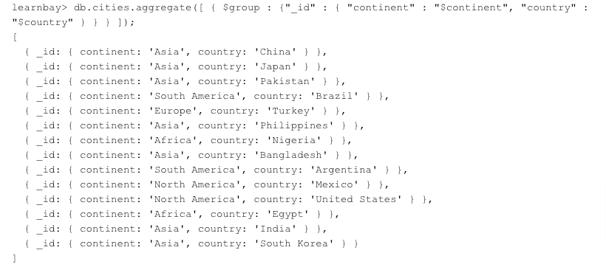

1. Get records with the highest population and the lowest population.

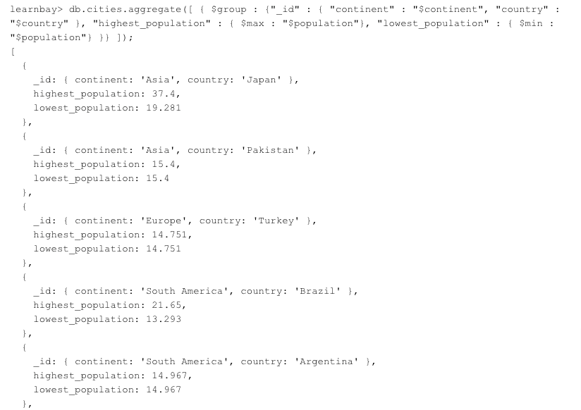

1. Get records with the highest population and the lowest population and show their names.

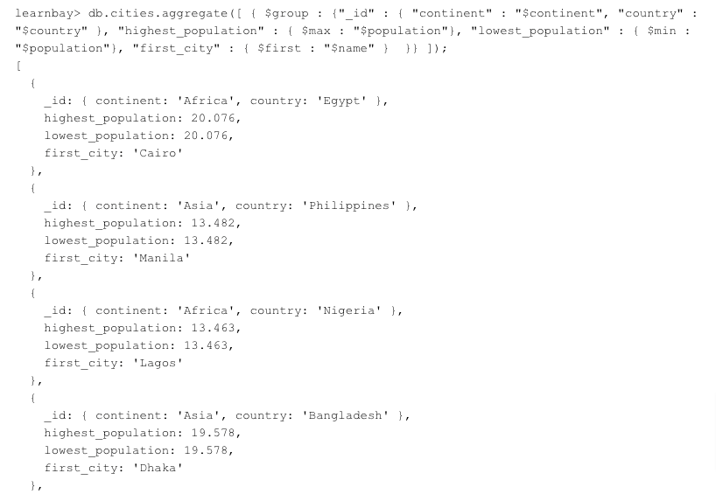

1. Get records with the highest population and the lowest population and show their names. Show the total count of the cities.

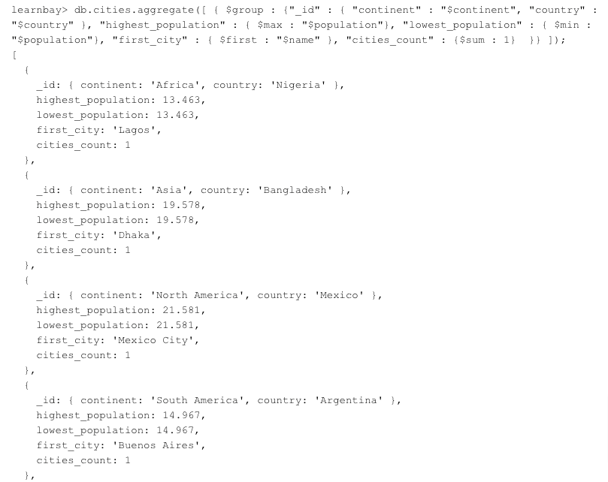

1. Show the Avg population of all the cities

